

A PROJECT REPORT ON
JAP COUNTER APP
A Mindful Mantra Chanting & Spiritual Habit-Tracking
Android Application

Submitted by | Nikhil Bhanderi | 92301733054
Guided by | Shamsaagazarzoo Alam
Subject | MPC -01CT0716
Academic Year | 2026 – 2027

MARWADI UNIVERSITY, RAJKOT

Information and Communication Technology
2025-26

CERTIFICATE
This is to certify that the project entitled JAP COUNTER APP has been carried out by Nikhil Bhanderi(92301733054) under my guidance in partial fulfillment of the degree of Bachelor Engineering in Information and Communication Technology (7th Semester) of Marwadi University, Rajkot during the academic year 2026.

Date : 09-09-2026

Internal Guide Head of the Department
Mr. Shamsagazarzoo Alam Prof . C. D. Parmar
Subject Co-ordinator Head of Department ICT
C.T.O. Ally Soft Solutions Engineering

Table of Contents
1. Introduction 3
2. Features 4
3. Technology Stack & Architecture 6
4. Project Structure 7
5. Screenshots & Description 8
6. Future Scope 11
7. Conclusion 12

1. Introduction
Jap Counter App is a serene, spiritually themed Android application built to support mindful chanting, mantra counting, and spiritual habit tracking. In many Indian spiritual traditions, practitioners repeat a mantra or name of the divine a fixed number of times (commonly 108 or 1008) using a physical rosary (mala). This application digitises that practice, giving users a calm, distraction-free way to count their chants while preserving the meditative spirit of the exercise.
The app was designed with a warm Saffron, Sandalwood, and Cream colour palette to keep the experience visually soothing, and is built using modern Android development practices — Jetpack Compose for the UI, an MVVM architecture, and local-first data persistence — so that it remains fast, private, and fully usable without an internet connection.
Objectives
• Provide a simple, elegant, and distraction-free digital counter for mantra chanting (jap).
• Allow users to set custom mantra names and target counts (108, 1008, or any custom value).
• Maintain a complete history of chanting sessions, including in-progress and completed sessions.
• Allow users to resume an interrupted session at any time without losing progress.
• Celebrate the completion of a chanting goal with a dedicated, encouraging completion screen.
• Deliver a calm, spiritually appropriate visual design suitable for meditation and prayer.

2. Features
Serene Animated Splash Screen
The app opens with a glowing “Om” emblem accompanied by a gentle breathing pulse animation and a soothing gradient background, setting a calm and spiritual tone before the user even begins chanting.
Mindful Jap Counter
• An intuitive, large circular tap counter that responds to every touch with a satisfying, calming interaction.
• A real-time percentage progress ring that fills as the user gets closer to their target.
• Quick target-count shortcuts for the traditional counts of 108 and 1008, plus support for any custom target.
• A dropdown with auto-suggestions of previously used mantra names, so recurring practices are quick to start.
History & Task Tracking
• A complete, chronological history of chanting sessions — both completed and in-progress.
• Sessions are grouped by date (Today, Yesterday, and so on) with completion timestamps and progress indicators.
• Any in-progress session can be resumed at any time, exactly where the user left off.
• Individual history records can be deleted, or the entire history cleared, with a confirmation dialog to prevent accidental data loss.
Completion Celebration
When a chanting target is reached, the app transitions to a dedicated completion screen that celebrates the achievement, with one-tap options to restart a new session or view the session in the history log.
Spiritual Aesthetics
Every screen uses a warm Saffron, Sandalwood, and Cream colour palette, chosen specifically to promote tranquility and focus, making the app feel at home alongside meditation, prayer, and other mindfulness practices.

3. Technology Stack & Architecture
Jap Counter App is built entirely with modern, native Android tooling. The technology choices prioritise a smooth, reactive UI, reliable offline-first data storage, and a clean separation of concerns between the interface and the underlying business logic.
Category | Detail
Language | Kotlin
UI Toolkit | Jetpack Compose (Material 3)
Architecture | MVVM (Model-View-ViewModel) + Repository Pattern
Local Persistence | Room Database (chanting history & session logs) and DataStore Preferences (active session state, current counts, user profile data)
Asynchronous Handling | Kotlin Coroutines & Flow / StateFlow
Navigation | Jetpack Compose Navigation (NavHost)
Minimum SDK | Android 7.0 (API Level 24)
Target SDK | Android 15 (API Level 35)
Architecture Overview
The application follows the MVVM pattern layered with a Repository. The UI (Compose screens) observes StateFlow exposed by a central JapViewModel, which owns all business logic and mediates between the UI and the data layer. The Repository abstracts the Room database and DataStore preferences behind a single API, so the ViewModel never talks to persistence directly. This keeps the UI layer simple and reactive, and makes the data layer easy to test or swap out.

4. Project Structure
The codebase is organised by responsibility, following standard Android/Compose conventions, which keeps data, UI, and navigation cleanly separated:
data/
JapPreferences.kt — DataStore preferences for the active session
JapSession.kt — Session data model
local/
JapDatabase.kt — Room database definition
JapHistoryDao.kt — Room DAO operations
JapHistoryEntity.kt — History table entity
repository/
JapHistoryRepository.kt — Repository layer for data operations
ui/
components/NavComponents.kt — Custom app bars & navigation headers
history/JapHistoryScreen.kt — Jap history & past records screen
navigation/JapNavGraph.kt — Compose navigation graph & routes
screens/
SplashScreen.kt — Animated spiritual splash screen
WelcomeScreen.kt — User onboarding screen
SetupScreen.kt — Mantra & target configuration
CounterScreen.kt — Main interactive jap counter screen
CompletionScreen.kt — Jap completion celebration screen
theme/
Color.kt, Theme.kt, Type.kt — Saffron & Sandalwood palette, Material 3 theme, typography
viewmodel/JapViewModel.kt — Central ViewModel handling business logic
MainActivity.kt

5. Screenshots & Description
The following screens illustrate the core user journey of Jap Counter App — from the moment it launches, through configuring and running a chanting session, to reviewing past sessions in history.
  1. Splash Screen  A calm, gradient splash screen displays the app name in the signature saffron colour while the app initialises, immediately establishing the tranquil tone of the experience. | 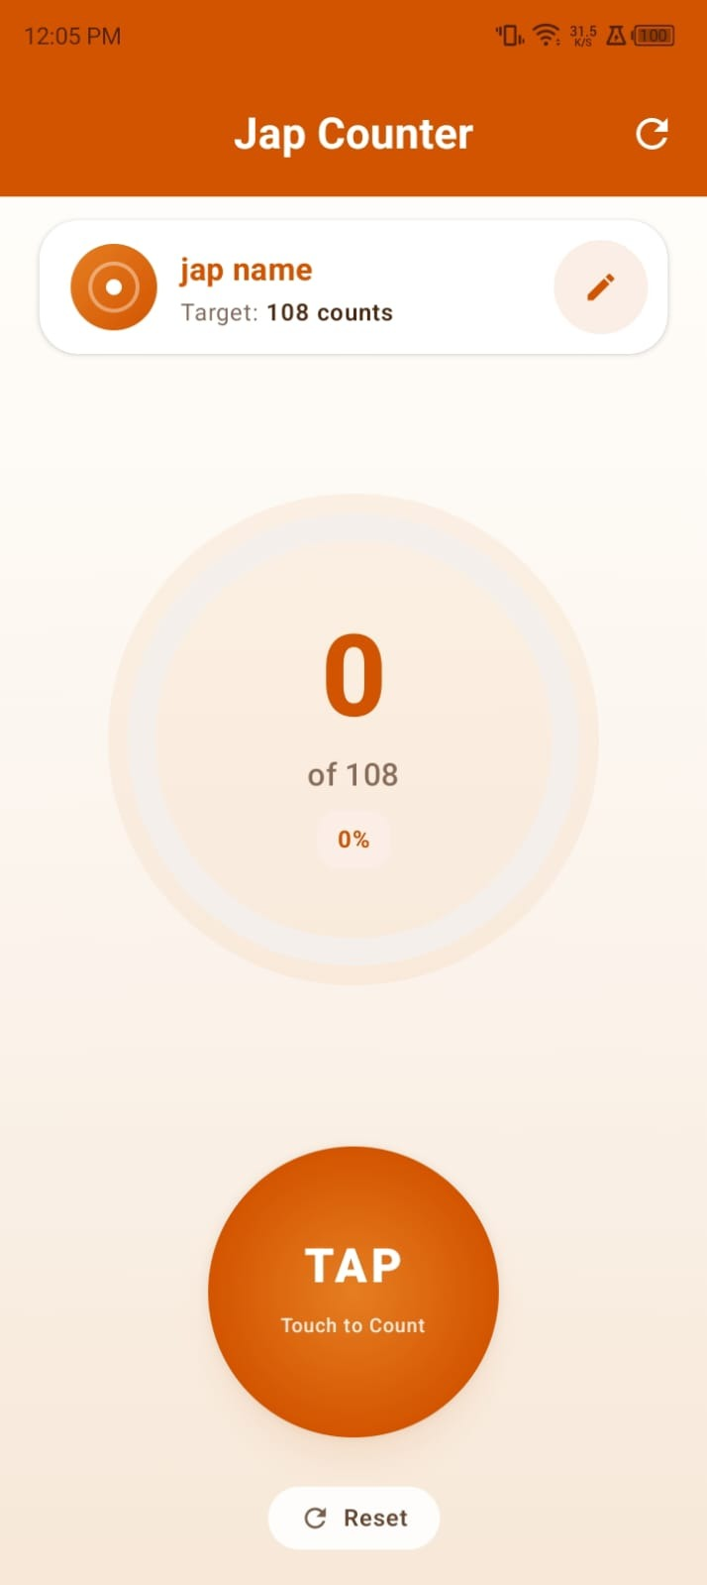  2. Jap Counter — Home  The main counting screen shows the active mantra name, its target count, and a large circular progress ring around a big central TAP button. The counter starts at 0 of the chosen target.

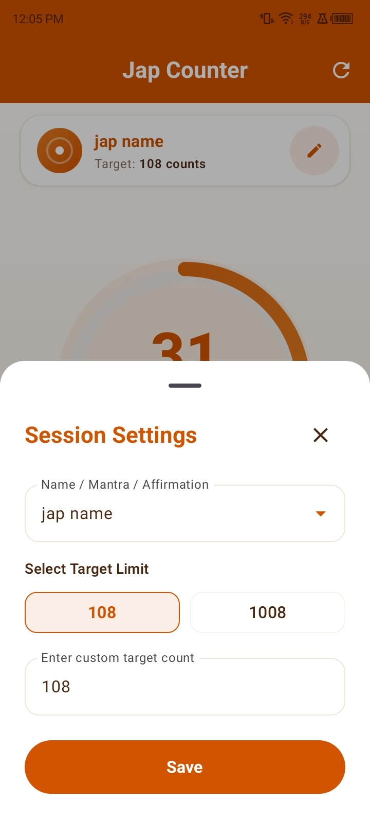  3. Session Settings  A bottom sheet lets the user type or select a mantra name from previous entries, and choose a target count — quick options for 108 and 1008, or any custom value entered manually. | 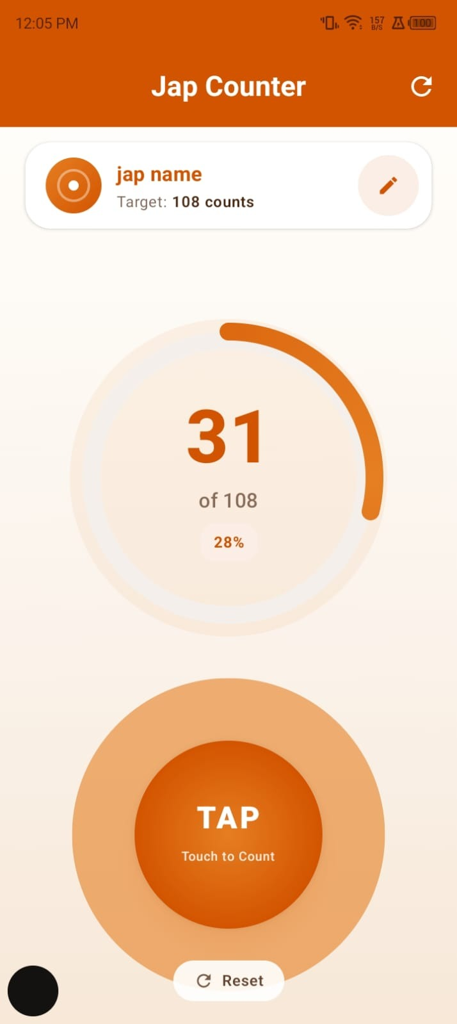  4. Counting in Progress  As the user taps, the count increases in real time and the circular progress ring fills proportionally, along with a live percentage — here shown at 31 of 108 counts, 28% complete.

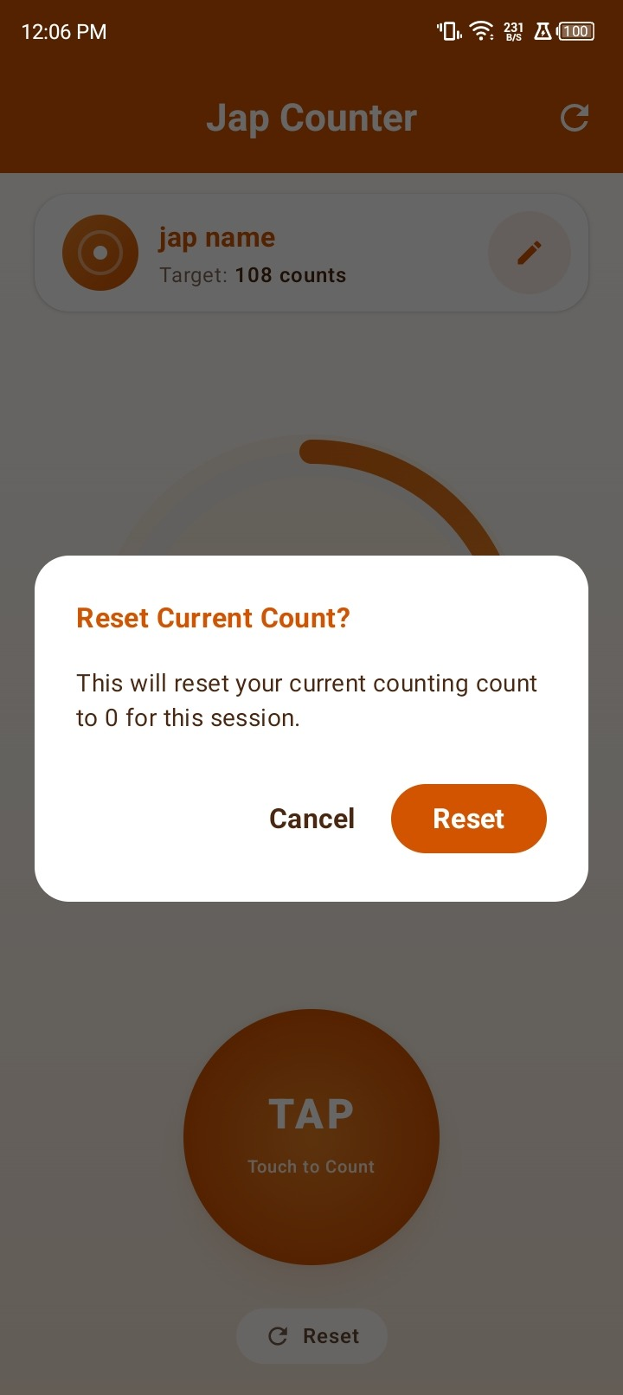  5. Reset Confirmation  Tapping Reset opens a confirmation dialog before the current session's count is cleared back to zero, preventing accidental loss of progress. | 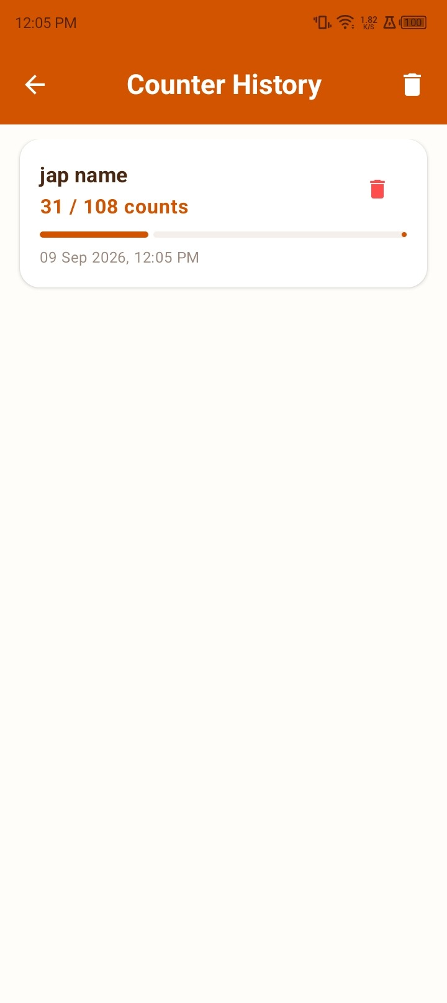  6. Counter History  The history screen lists past chanting sessions grouped with date and time stamps, showing each mantra name, its progress (e.g. 31 / 108 counts), and a visual progress bar; entries can be deleted individually or cleared entirely.

6. Future Scope
Jap Counter App already covers the essentials of digital mantra counting. A number of enhancements could extend it into a fuller spiritual companion app:
• Cloud Backup & Sync — Optional account-based sync so chanting history and streaks carry over across devices.
• Daily Reminders & Streaks — Configurable notifications and a streak tracker to encourage a consistent daily practice.
• Audio-Guided Chanting — Built-in audio tracks or a metronome-style beat to pace group or guided chanting sessions.
• Voice / Mic-Based Counting — Automatic count detection through spoken repetition, for hands-free jap during other activities.
• Wear OS / Smartwatch Support — A companion watch app or tile so counting doesn't require holding a phone.
• Widgets — A home-screen widget for one-tap counting and at-a-glance progress without opening the app.
• Multi-language Support — Localisation of the interface and mantra library into Hindi, Gujarati, and other regional languages.
• Meditation Timer Integration — An optional silent meditation/breathing timer that can precede or follow a chanting session.
• Data Export & Analytics — Exportable history (CSV/PDF) and simple analytics such as weekly/monthly chanting trends.
• Dark Mode — A low-light, dark-themed variant of the palette for night-time or early-morning practice.

7. Conclusion
Jap Counter App demonstrates how a simple, everyday spiritual practice can be thoughtfully translated into a digital experience without losing its calm and meditative character. Built on a modern MVVM architecture with Jetpack Compose, Room, and DataStore, the app is fast, works fully offline, and keeps the user's chanting history safely on-device. Its warm Saffron and Sandalwood aesthetic, intuitive tap-to-count interaction, and thoughtful history tracking make it a genuinely useful companion for anyone maintaining a regular jap or mantra practice, while its clean, modular codebase leaves plenty of room for the future enhancements outlined above.

